



**In a Box**

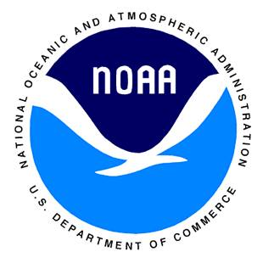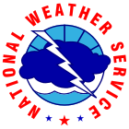

National Weather Service

Weather Forecast Office Twin Cities

Chanhassen, MN

Project by: Nicholas Grondin, Hollings Scholar Intern

Summer 2015



Teacher’s Guide

Teacher Name: _________________________________

School: ________________________________________

District Name: ___________________ District #: ______